Project Shell for Mackinac Gnomes
By: Neal Kauffman

Mackinac Gnomes Semeter Project

Gantt Chart Lab
By: Neal Kauffman
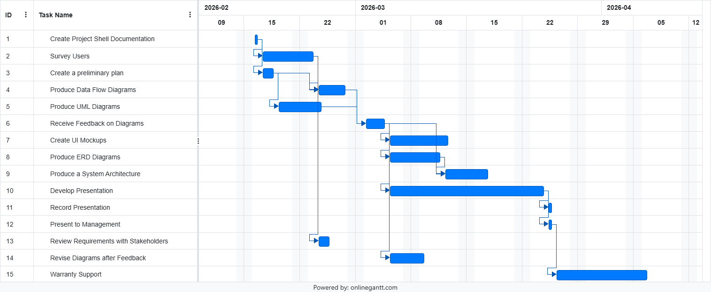
Work Breakdown Gantt Chart
CSV: See Page 2
(Also Attached)
Figure 1 Gantt Chart
Name | Start | Finish | Duration | %Complete | Predecessors
Create Project Shell Documentation | 2/16/2026 | 2/16/2026 | 1 day | 0
Survey Users | 2/17/2026 | 2/23/2026 | 5 days | 0 | 1FS
Create a preliminary plan | 2/17/2026 | 2/18/2026 | 2 days | 0 | 1FS
Produce Data Flow Diagrams | 2/24/2026 | 2/27/2026 | 4 days | 0 | 2FS,3FS
Produce UML Diagrams | 2/19/2026 | 2/24/2026 | 4 days | 0 | 3FS
Receive Feedback on Diagrams | 3/2/2026 | 3/4/2026 | 3 days | 0 | 4FS,5FS
Create UI Mockups | 3/5/2026 | 3/12/2026 | 6 days | 0 | 6FS
Produce ERD Diagrams | 3/5/2026 | 3/11/2026 | 5 days | 0 | 6FS
Produce a System Architecture | 3/12/2026 | 3/17/2026 | 4 days | 0 | 6FS,8FS
Develop Presentation | 3/5/2026 | 3/24/2026 | 14 days | 0 | 6FS
Record Presentation | 3/25/2026 | 3/25/2026 | 1 day | 0 | 10FS
Present to Management | 3/25/2026 | 3/25/2026 | 1 day | 0 | 10FS
Review Requirements with Stakeholders | 2/24/2026 | 2/25/2026 | 2 days | 0 | 2FS
Revise Diagrams after Feedback | 3/5/2026 | 3/9/2026 | 3 days | 0 | 6FS
Warranty Support | 3/26/2026 | 4/6/2026 | 8 days | 0 | 12FS

Survey Feedack & Analysis

By: Neal Kauffman

Feedback Received
During the review period, four peers provided constructive criticism on the system survey. Their feedback focused on data flexibility and professional formatting.

- Xavier Infante: Enjoyed the inclusion of refund and replacement status fields, noting they are vital for addressing recurring customer delivery issues.

  - Hey Neal, your questionnaire form really topped off with good info for the gnome company but more importantly the refund/replace status info really helps with customers what are always having trouble with missing and bad product delivery service, but it’s good for employees to help out with this problem.

- Ethan Gardner: Suggested changing the “instantly fix one issue” question from a dropdown to a short paragraph to avoid limiting user responses to pre-set categories.

  - Hello Neal, overall I think your survey is good and has the use of variety in answering question. One improvement i can think of is the question, If you could instantly fix one issue with the current spreadsheet, what would it be? The answer would be better if it was a short paragraph instead of a drop box choice because the employee could have an issue with the current spreadsheet that isn't part of the choices provided.

- Izzy Bledsoe: Provided positive feedback on the feature ranking section, however also recommended making the final question optional.

  - Hi Neal, I really like how your questions were very specific and in depth, the ranking the importance of new features in the system seems like a great way to get data about specific features users want. Maybe the last question doesn't have to be marked as required though but that's the only improvement I can think of.

- Daniel Parker: Identified a minor formatting error (an unnecessary indent)

  - The survey overall is great. My only thin gis that one of the questions has a unneccesary indent at the beginning. For uniform purposes I would fix that small issue.

Feedback Given
I have provided detailed reviews for four classmates, focused on survey logic, professional tone, and adherence to business rules.

- Ethan Gardner: I recommended accounting for more than three organizational roles and reformatting rating scales for better clarity. I also recommend rewording a search-related question for better flow.

  - Good form, a few bits of feedback, 1) There are more than 3 roles that may be taking this survey, 2) consider reformatting the rating questions to have the scale labels under the question for clarity. 3) Highly recommend rewording the last question "What search up the most on from the Ordering System. Example is searching for a refund status."

- Ryan McKevitt: I advised against “funny” options like “gnome” for a job role to maintain a professional tone. I also noted a functionality problem with a question that limited responses to one response per column, that combined with only four columns for five criteria could skew data results negatively.

  - Pretty good survey, though having 'Please don't select more than one response per column" is going to skew results negatively for you as it limits the honesty that can be given, also having 4 columns with 5 criteria does not allow for all criteria to be answered. I would also recommend rethinking the "gnome" option on job roles. It does not give any usable information and it is best not to get too "funny" in a professional document.

- Julia Haines: I provided a technical tip for hyperlinking her URL. I also pointed out a great question in her survey that identified an existing business rule regarding the sale of a single gnome that was in the project overview.

  - Firstly, you may want to edit the response to add the link as a hyper link (9th button from the left in these canvas discussions). The First question is very astute and reflects a currently existing business rule.

- Xavier Infante: I suggested reducing short-answer questions in favor of closed-ended data points to make the data gained easier to use in analysis.

  - Hi Xavier, Great form, The only thing I would recommend thinking about is having less short answer questions, that may be easier to collect helpful data that way!

Results and Analysis

The Survey results come from three key roles- Sales(man), Accountant, and Creator- confirming that the current spreadsheet is a significant issue. 75% of surveyed users rated the current system’s efficiency at only a combined average of 2.6 out of 5 stars, despite 75% of respondents accessing the spreadsheet six or more times daily (see Figure 1.1). The high frequency of use along with the low efficiency indicates that the spreadsheet is no longer supporting the company’s growth.
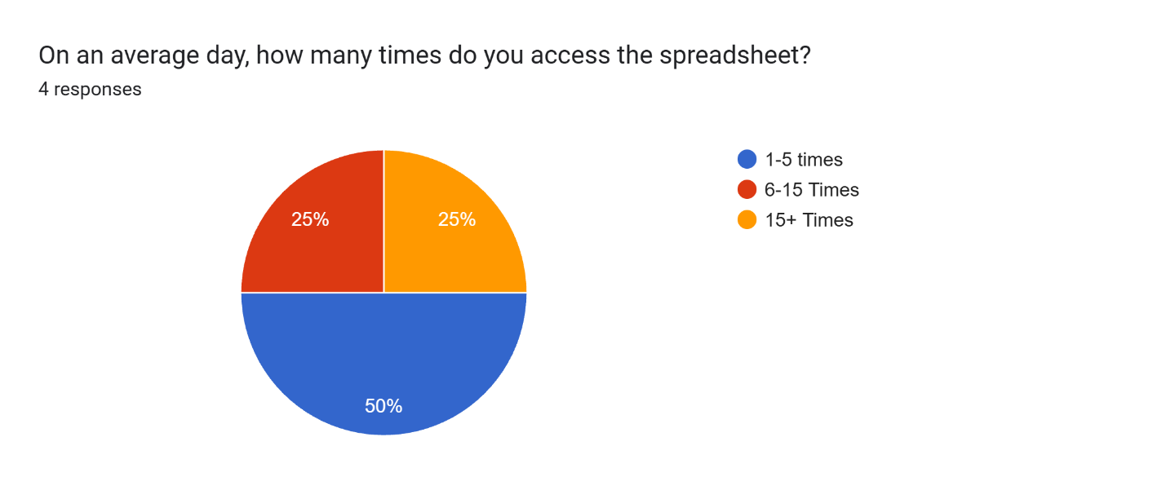
Figure 2.1 Daily Usage

A Critical finding is the 50/50 split in automation preference, as half the respondents need automated shipping labels, with the other half wanting auto-calculating weekly sales (as shown in Figure 2.1). This suggests that the new system should focus primarily on logistics and finance. 75% of respondents said that verifying payment amounts and communicating updates to the team are the most time-consuming steps in the refund/status update process. Lastly I will consider the addition of “Commission Tracking” and “Refund Status Macros” to the new system as these were explicitly requested in the open-ended response data.
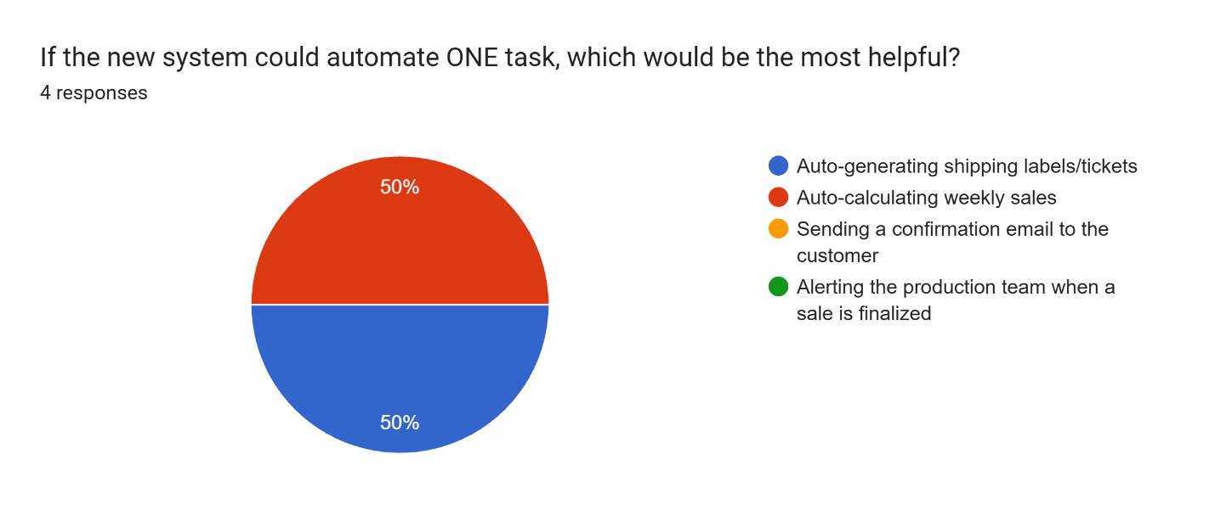
Figure 3.1 Automation

Questionnaire Changes

- Fix Indentation issue - Completed
- Will leave the “one issue to fix” question as multiple choice for targeted data collection.
- Will include a disclaimer in the heading to add “N/A” if the last question does not apply.

Data Flow Diagram Deliverable

By: Neal Kauffman

Context Diagram
Existing Order System Diagram…
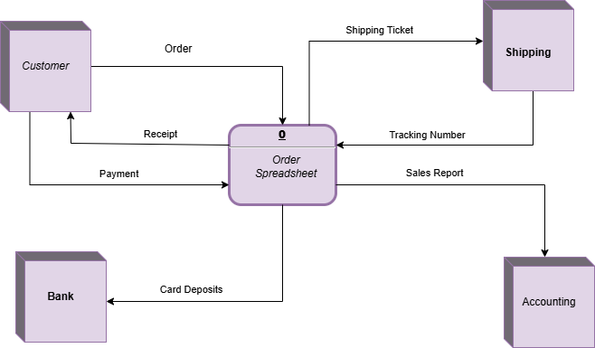
Figure 4 Existing System Context Diagram

Diagram 0
Proposed Order System Diagram
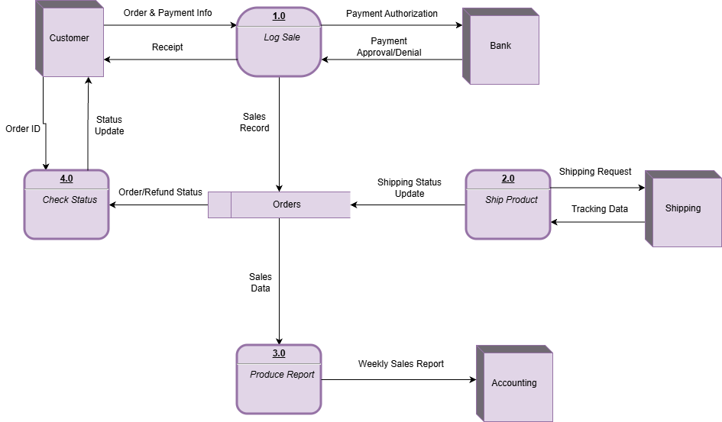

Figure 5 Proposed System 0 Diagram

Level 1 Explosion
Log System Explosion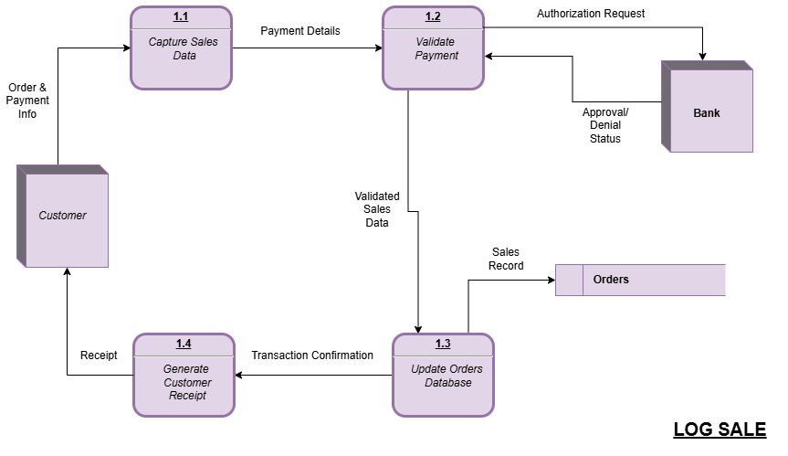
Figure 6 LOG SALE Explosion Diagram
Ship Product Explosion
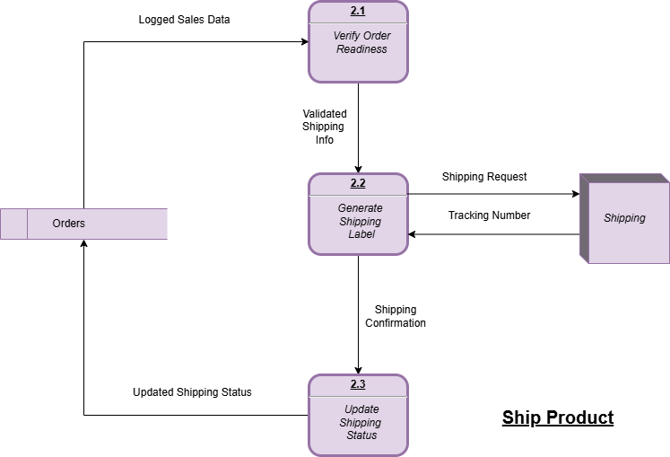
Figure 7 SHIP PRODUCT Explosion Diagram

Process Diagram
Label | LOG SALE
Entry Type | Process
Description | Captures and validates transactional data for a single gnome sale
Process # | 1.0
Description | Input data flows: ORDER & PAYMENT INFO, PAYMENT APPROVAL/DENIAL  Output data flows: PAYMENT AUTHORIZATION, SALES RECORD, RECEIPT  For each ORDER & PAYMENT INFO:  Output PAYMENT AUTHORIZATION to Bank  If PAYMENT APPROVAL/DENIAL = Approved THEN  Output SALES RECORD to Orders Data Store  Output RECEIPT to Customer  Else  Notify Customer of Payment Error
Notes: | All sales restricted to one gnome per business rule.
Table 1 LOG SALE Process Diagram

Decision Table
Conditions | Rule 1 | Rule 2 | Rule 3
Sale Is Logged | Y | Y | Y
Payment Received and Approved | Y | Y | N
Shipping Label Created | Y | N | -
Actions | - | - | -
Ship Product | X
Do Not Ship |  | X | X
Table 2 SHIP PRODUCT Decision Table

Email to Client
Mackinac Gnomes,
The attached documentation is regarding the system analysis and design for your new order system. This deliverable includes a comprehensive set of Data Flow Diagrams and Tables representing both your existing workflow and the proposed automated system.
Summary of Deliverables:
- Context Diagram showing high-level views of the current spreadsheet-based system.
- Diagram 0 showing a detailed breakdown of core internal processes: Log Sale, Ship Product, Produce Report and Check Status.
- Level 1 Diagrams showing specialized ‘explosions’ of the sales and shipping workflows to ensure balanced data movement.
- Logic documentation including a detailed process pseudocode for system entry and a decision table for shipping criteria
It took approximately 8 hours to finalize these diagrams/tables to ensure accuracy to your specific business rules. These documents will serve as the technical blueprint for upcoming phases.
Best Regards,
Neal Kauffman, System Analyst

UML Diagram Lab Deliverable

By: Neal Kauffman

Use Case Diagram
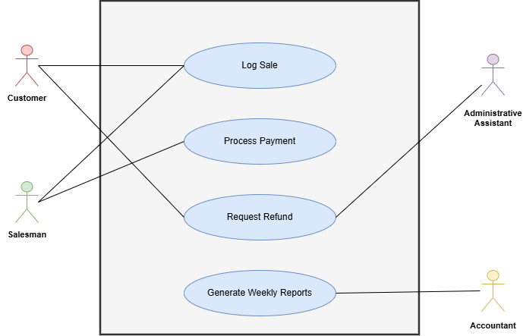
Figure 8 Use Case Diagram

Activity Diagrams
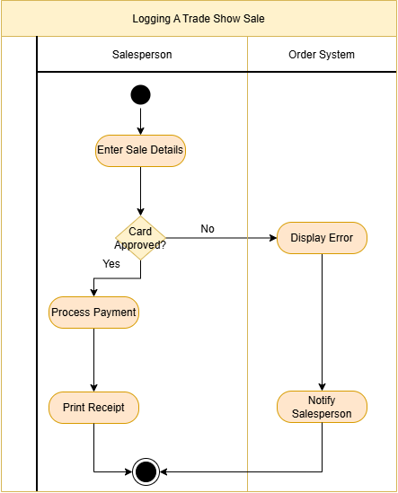
Figure 9 Sale Log Activity Diagram

2.
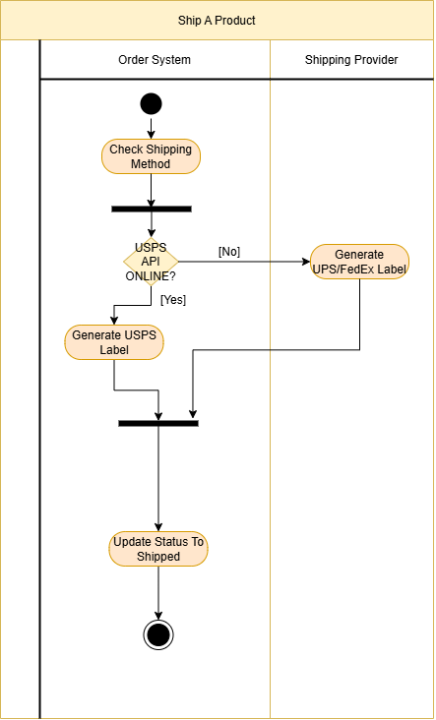
Figure 10 Product Shipment Activity Diagram

3.
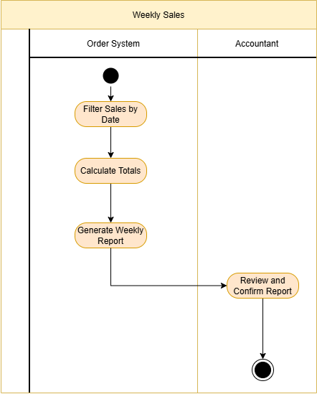
Figure 11 Weekly Sales Activity Diagram

Class Diagram
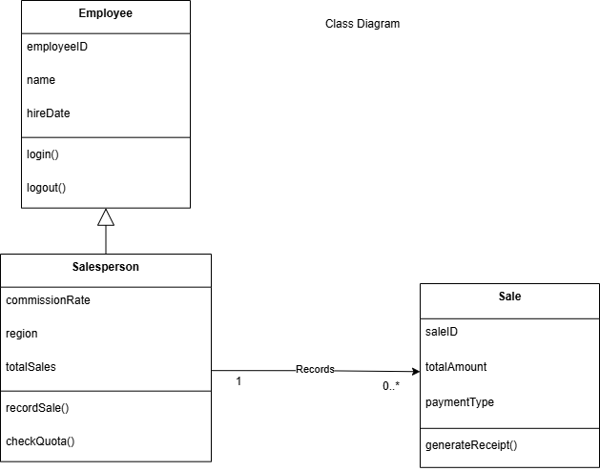
Figure 12 Sales Employee Class Diagram

Sequence Diagram
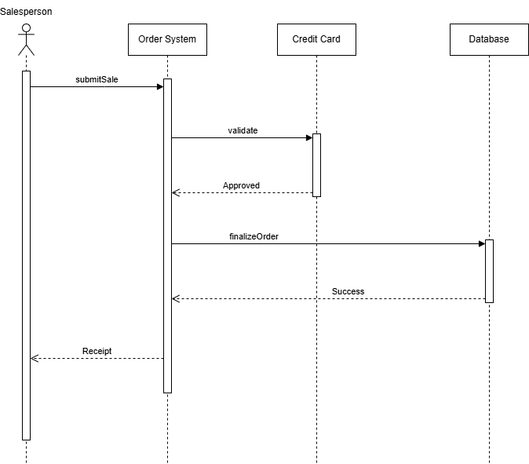
Figure 13 Complete Sale Sequence Diagram

Email to Client

Mackinac Gnomes,
The attached documentation is regarding the system analysis and design for your new integrated order and logistics system. This deliverable includes a comprehensive set of UML Diagrams representing both the internal data and the proposed automated workflows.
Summary of Deliverables:
- Use Case Diagram: showing a high-level view of the interactions between Customers, Salespeople, Accountants, and the system.
- Activity Diagrams: providing a detailed breakdown of core operational processes: Logging a Trade Show Sale, Shipping a Product, and Generating Weekly Sales Reports.
- Class Diagram: showing the inheritance relationship between Employees and Salespersons to ensure balanced data movement.
- Sequence Diagram: including a timeline of a sale, including credit card authorization, and finalizing the order into the system database.
It took approximately 8 hours to finalize these diagrams to ensure accuracy to specifications and business rules. These documents will serve as the technical blueprint for the upcoming phases.
Best Regards,
Neal Kauffman, Systems Analyst

UI Design- Wireframes

By: Neal Kauffman

Landing Page
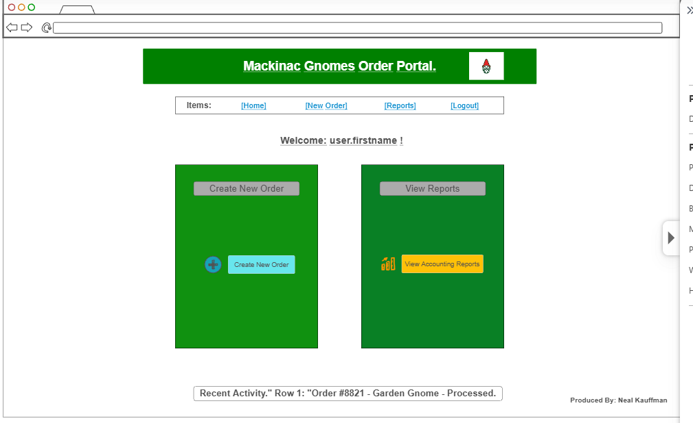
Figure 14 Landing Page

Order Entry- Happy Path

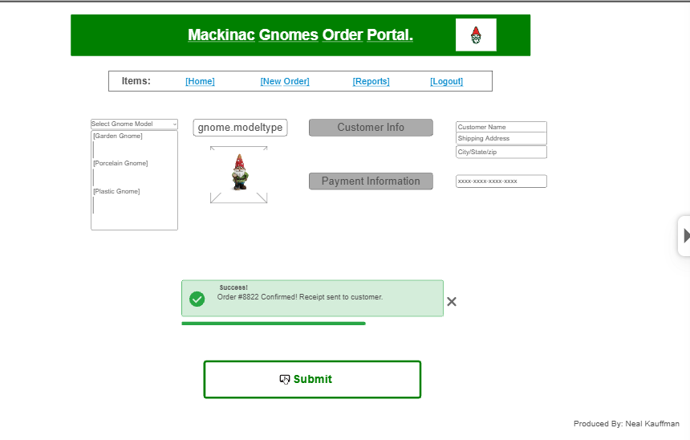
Figure 15 Happy Path

Order Entry- Error

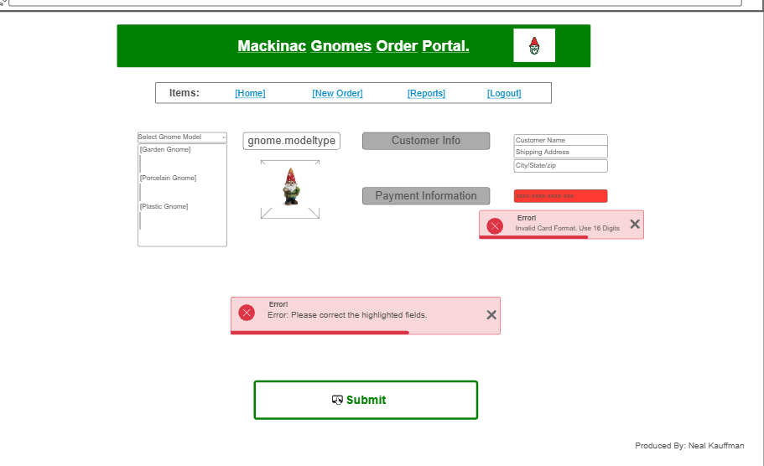
Figure 16 Unhappy Path

Reporting
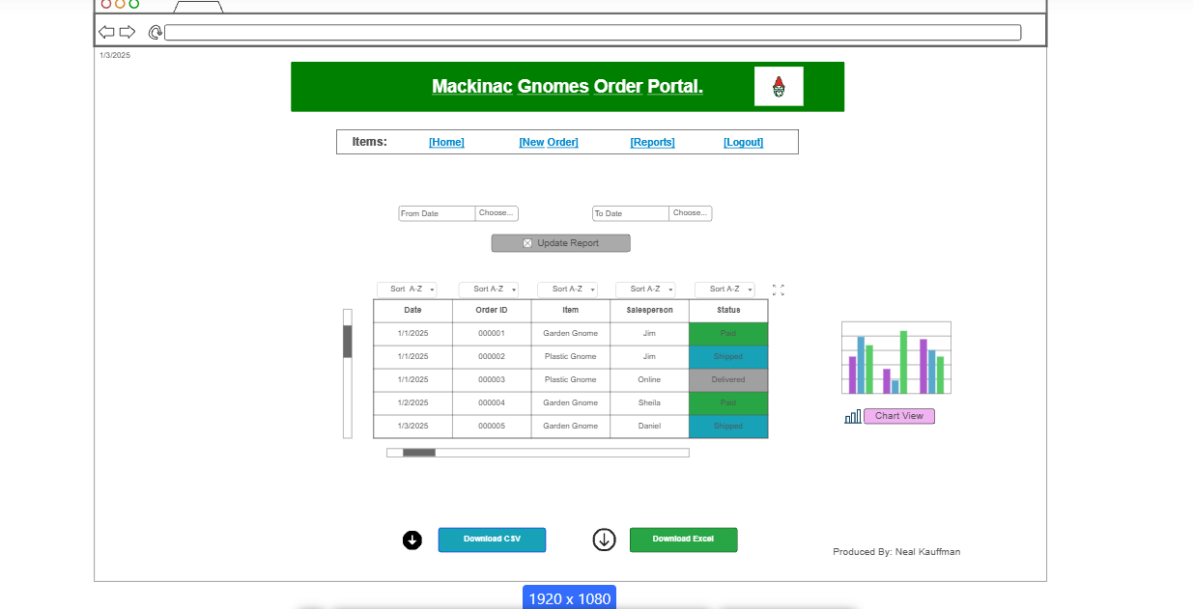
Figure 17 Reporting Page

Entity Relationship Diagram (ERD) Lab

By: Neal Kauffman

ERD Diagram
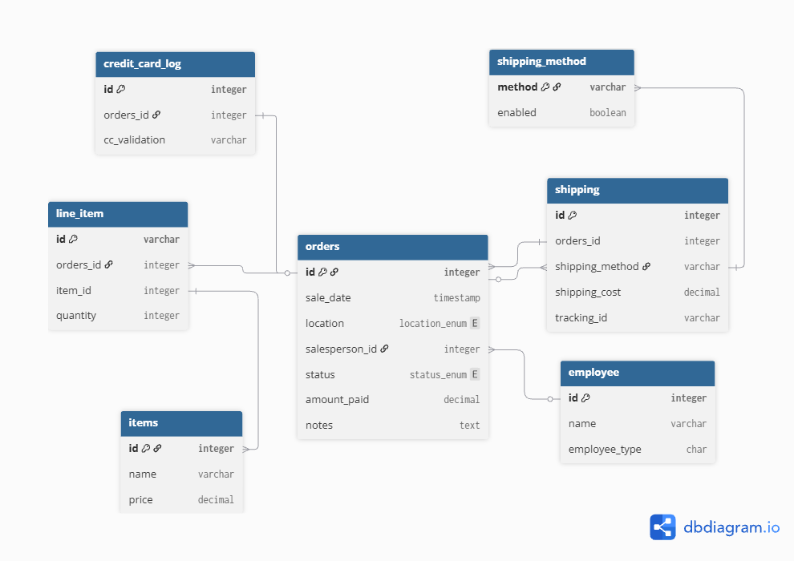
Figure 18 Diagram

Table Schema 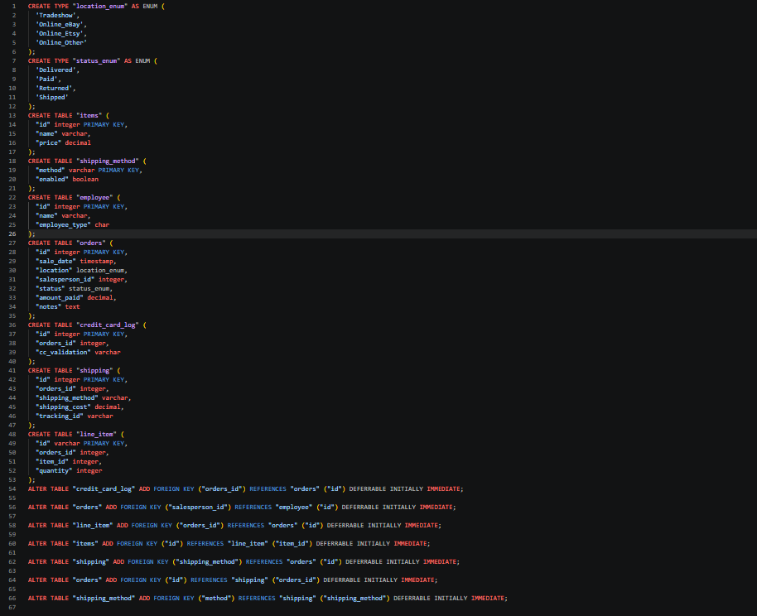
Figure 19 Table Schema

Sample Query- Orders
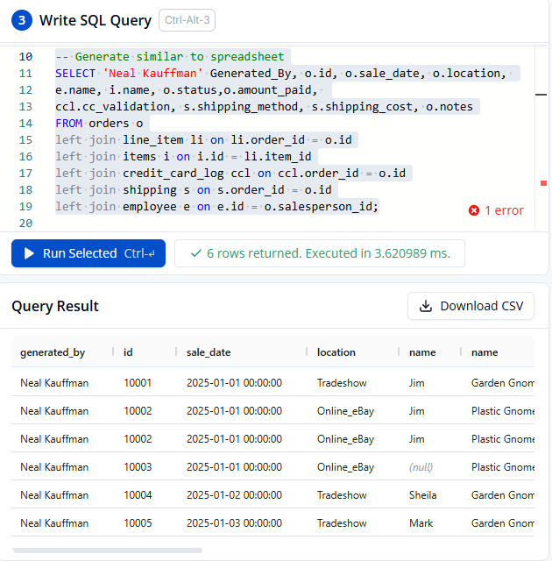
Figure 20 Orders Query

ERD CSV
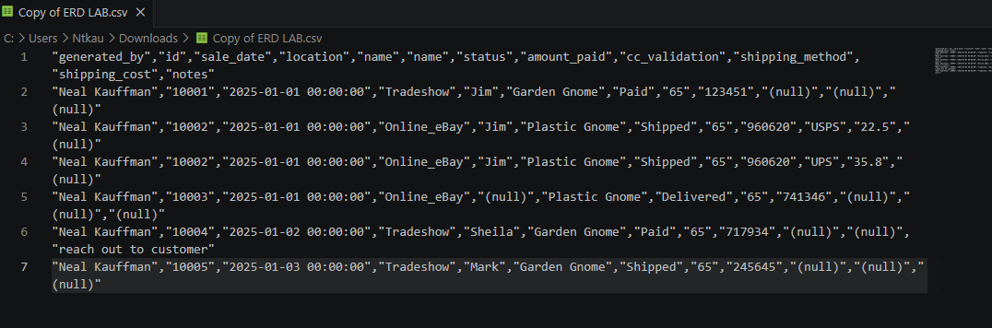
Figure 21 CSV

Client Email
Dear Mackinac Gnomes Team,
I am pleased to present the data model designed to support your new order entry system. As your business transitions from manual spreadsheet tracking to a structured database, these diagrams provide the necessary technical information for better reporting and complex queries through a database.
The following deliverables are included for your review:
- Entity Relationship Diagram (ERD): This visual diagram uses crow’s foot notation to illustrate the relationships between the seven core entities: orders, line items, employees, items, shipping, shipping items, and credit card logs.
- Schema Table: I have included the full SQL export for your engineering and database team to implement this system immediately.
- Third Normal Form (3NF) Conversion: To Demonstrate the efficiency of the new database, I converted the first five entries of the existing spreadsheet into 3NF, ensuring that data is entered only once. I have included a sample query and CSV output to show this.
Best Regards,
Neal Kauffman- System Analyst

System Architecture Deliverable

By: Neal Kauffman

Diagram
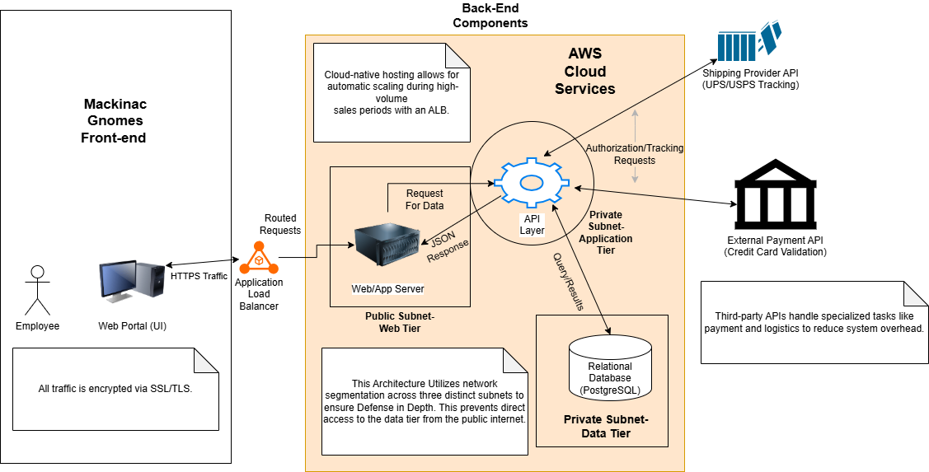
Figure 1 System Architecture Diagram

Memo
To: Mackinac Gnomes
From: Neal Kauffman, Systems Analyst
Date: April 30, 2026
Subject: System Architecture and Implementation Plan

The proposed architecture for the Mackinac Gnomes system is designed to move the company away from manual spreadsheets and onto a secure, web-based platform. This design focuses on making the system east to scale as the business grows.
I have chosen a cloud-based, three-tier architecture hosted on AWS. My main decisions for this layout include:
- Cloud Hosting: I decided the system should be hosted in the cloud rather than on premises. Cloud hosting eliminates the need to purchase and maintain physical hardware, while also providing the “elasticity” needed to handle web traffic spikes during peak seasons easier than a local server.
- AWS Platform: I selected AWS as the hosting platform due to its fantastic security tools and its ability to easily host the PostgreSQL database.
- Application Load Balancer (ALB): I placed an ALB at the entry point of the cloud environment. This is a requirement for “automatic scaling,” as it handles traffic spikes during said peak seasons so that the system doesn’t crash.
- Subnet Segmentation: I divided the system into a public and two private subnet tiers. This ensures that the API layer and the PostgreSQL database layer are hidden from the public internet, providing a much higher level of security than a standard flat network. The data tier additionally gets a separate isolated subnet for added security to customer and order data.
Implementation Plan:
The rollout will happen in stages. First we will set up the data and application tiers to make sure the backend logic is working. Next, we will deploy the web portal and connect it through the load balancer. Finally, we will link the system to the third-party banking and shipping providers. This modular approach keeps the system secure and allows us to test each part before the full launch.

[Semester Project & Presentation]

